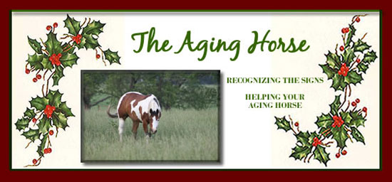
Just as we grow old and lose some of our functional abilities, so do horses. Aging horses experience the same aliments as people do when they grow older. The "external" symptoms of aging are easy to recognize. Your horse may lose the lustrous coat of youth, develop brittle hooves and appear slow and stiff due to arthritic conditions. Less easy to identify are the changes taking place inside your horse's body. These may include reduction of vision, deafness; sclerosis (hardening of the internal tissues); build-up of metabolic waste; swelling in the extremities; inflammatory bowel disease; diverticular disease; degenerative joint disease (osteoarthritis); bone density decreased (osteoporosis); hypertension (high blood pressure); heart disease, thrombosis of the veins; muscle wasting; breathing problems and kidney problems.
Thanks to a better understanding of how people age and why, we can decrease the aging affects. We can do the same for our horses. In general, the first year of a horse's life is equal to 10 human years. Following this, each horse year is equal to two human years. Thus an eight to ten year old horse is like a 30 year old person; a 20 year old horse is like a 50 year old person, and a 30 year old horse is like a 70 year old person.
The tendencies that your horse inherits (different equine breeds age at different rates), lifestyle and previous trauma are all contributing factors in the rate and extent of aging. With understanding of the changes taking place in your horse's body, and how best to deal with them, you can help ensure an enjoyable healthy life.
RECOGNIZING THE SIGNS IN AGING HORSES
- Vision: A bluish cast to your aging horse's eyes is a normal feature of aging and usually does not cause visual impairment. However, a milky white appearance may mean your horse has cataracts, which can lead to blindness. Your veterinarian will be able to tell you if your horse has cataracts and how best to deal with them.
- Hearing: Losing the ability to hear clearly is common among older horses. If your aging horse stops responding in the normal way to your voice, it is likely that he or she may not be hearing as well.
- Changes in eating habits: Older horses are more likely to develop tooth and gum disease. This can often be painful, causing a loss of desire to eat. Waning activity levels will also cause a reduction to appetite.
- Weight gain: As with humans, a horse's metabolism slows down with advancing age. This may cause weight gain. Giving your horse a high quality age-appropriate feed will help keep his weight under control.
- Weight loss: Sudden weight loss or continual weight loss is reason for concern and should be checked out with your veterinarian. Losing weight is often a sign of an internal problem that needs to be addressed promptly.
- Lethargy: As a horse grows older, you will likely see a decline in the amount of energy he expends. Older horses tire faster. This is not usually a cause for concern unless the tiredness is accompanied by other symptoms.
- Stiffness: Just as aging humans become less flexible, so do aging horses. Stiffness in the leg, hip and shoulder joints is common. This may be normal "wear and tear," or it could be a sign of arthritis. Your veterinarian will be able to provide a professional opinion and appropriate treatment.
Your horse's response to aging will depend on his / her breed, predisposition to illness and disease due to hereditary factors, breed life expectancy, lifestyle and general state of health prior to entering the senior years. You can help your aging horse by observing the following tips:
- Be aware of the ailments that can affect your aging horse and always consult your veterinarian if you have concerns.
- Pay attention to your horse's diet. make sure that you are providing nutritious food in appropriate quantity. (Many horses require smaller meals as they age and don't expend as much energy.)
- Make sure that your horse is drinking enough high quality water to prevent dehydration.
- Provide an effective lifestyle-enhancing supplement to your horses diet.
- Constantly monitor your horse for any signs of lameness. Avoid performance sports if your horse is lame and remember that masking pain with drugs when your horse is lame will increase risk of greater injury.
- Avoid excessive use of common pain medications as they actually promote tissue degeneration when used on a long-term basis.
- Make sure your hrose gets enough exercise. While your horse may look like he or she is tired, a little exercise is healthful and keeps the muscles (including the heart) well toned.
- Be especially gentle when grooming. Older horses have sensitive skin and may find grooming painful.
- Schedule regular veterinarian visits. Your horse's veterinarian will be familiar with the changes that take place in older horses and will be able to nip developing conditions in the bud.
- Respect your horse's seniority. Have a full check-up performed once a year prior to your insurance renewal.

